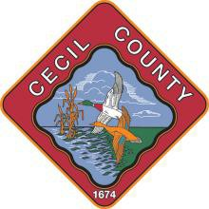

CALL TO ORDER
- Roll Call
CECIL COUNTY ETHICS COMMISSION
Cecil County Administration Building c/o Human Resources Department
200 Chesapeake Boulevard, Suite 2800
Elkton, Maryland 21921
(410) 996-5250 (phone)
1-866-230-2578 (fax)

AGENDA – OPEN SESSION
November 8th, 5:00 p.m.
Perryville Room (Public Access via Zoom)

- Open Session Agenda Review and Approve
- Minutes (August 3rd, 2021 Review and Approve

OLD BUSINESS
- 2019 Financial Disclosure Status. Review
- 2020 Financial Disclosure Status. Review
- 2019 Lobbyist Forms Status. Review
- 2020 Lobbyist Forms Status. Review
- Review Outstanding Financial Disclosure and Lobbying Forms Review and Approve

NEW BUSINESS
- Discussion for New Instructions for 2022 Financial Disclosure and Lobbyists Forms.
- Discussion to put Financial Disclosure and Lobbyists Forms online.
- Discussion of Public Stock Ownership.
- 2022 Meeting Schedule/Time.

CLOSED SESSION
- 19-03 and 19-04 Closure.
- Review Flagged Financial Disclosure Forms and Lobbying Forms.

MOTION TO ADJOURN

